**Lesson 6 Demo 7**

**Working with Ingress Controllers**



Steps to be followed:

1. Working with Ingress controllers

**Step 1: Working with Ingress controllers**

1. Install Ingress controllers on Bare Metal using the following command:

***kubectl apply -f https://raw.githubusercontent.com/\***

***kubernetes/ingress-nginx/controller-v0.46.0/deploy/\***

***static/provider/cloud/deploy.yaml***

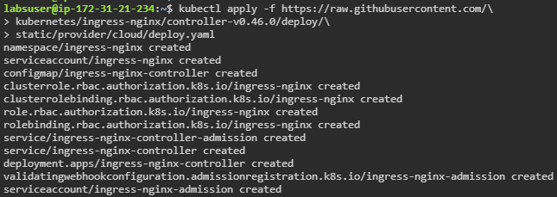

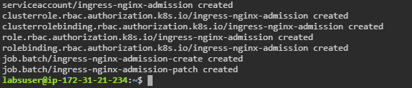

1. Verify the installation using the following command:

***kubectl get pods -n ingress-nginx -l \***

***app.kubernetes.io/name=ingress-nginx --watch***

